Programmable office diary

Project B6

Project realized by: Lang Blanka-Maria

Coordinator: Pop Diana

Table of contents

1. Introduction …………………………………………………………………………………….3
2. Design ………………………………………………………………………………………….3
2.1 Block scheme………………………………………………………………………………….3
2.1.1 Inputs and Outputs ………………………………………………………………………….3
2.1.2 Black Box……………………………………………………………………………………6
2.2 CU and EU…………………………………………………………………………………….7
2.3 Resources………………………………………………………………………………..…….8
2.3.1 List of resources……………………………………………………………………………..8
2.4 State diagram …………………………………………………………………………….….16
3. Justification for the chosen solution ………………………………………………………….17
4. Possible updates for a better efficiency……………………………………………………….17
5.Instructions…………………………………………………………………………………….17
6. Bibliography …………………………………………………………………………………17

1.Introduction

Design a programmable office diary that displays:
-year, month, day: with numbers;
-day: with letters;
-hour and minute: with numbers;
Ambient temperature in degrees Celsius.
The agenda will also be provided with an audible alarm associated with the hour and minute.

2.Design

2.1 Block scheme

2.1.1 Mapping the Inputs and Outputs

The first step that needs to be done is to map our Inputs and Outputs, which are essential for the implementation of the office diary.
Inputs:
In total we will have 20 inputs as it follows:
-clk: represents the clock impulse.
-reset: when reset will be activated our agenda will restart and will start to count everything from 0 or from the date we set.
-load: when load is activated its possible for the user to set up the date he/she wants.
-enable: when enable is activated then our agenda will work normally without the need to set it up.
-ora_zeci (on 4 bits ) represents the tens from the hours and its part of the watch component.
-ora_unitati (on 4 bits) represents the units from the hours and its part of the watch component.
-min_zeci (on 4 bits) represents the tens from the minutes and its part of the watch component.
-min_unit (on 4 bits) represents the units from the minutes and its part of the watch component.
-zi_zeci (on 4 bits) represents the tens from the day and its part of the calendar component.
-zi_unit (on 4 bits) represents the units from the day and its part of the calendar component.
-luna_zeci (on 4 bits) represents the tens from the months and its part of the calendar component.
-luna_unit (on 4 bits) represents the units from the months and its part of the calendar component.
-an_unit(on 4 bits) represents the units from the year
-an_zeci(in 4 bits) represents the tens from the year
-ziua_din_saptamana (on 4 bits) represents the number of day in the current week.
-al_ora_zeci(on 4 bits) represents the tens from the hour from the alarm
-al_ora_unit(on 4 bits) represents the units from the hour from the alarm
-al_min_zeci(on 4 bits) represents the tens from the minute from the alarm
-al_min_unit(on 4 bits)represents the units from the minute from the alarm
-alarm_on

Observations:
- I used multiple inputs on 4 bits, because we are working with digits from 0 to 9 and I found it easier to implement them and to work with them this way.
- Because our agenda is programmable I introduce an input “enable” ,when this is activated the user can easily set up any date he/she wants , but the input ”load” needs to be inactive to make the set up.
- Our office diary has also an alarm , so that’s why I used an input “alarm_on” which will become 1 when our alarm is set up and we want it to ring.

Outputs:
In total we will have 15 outputs as follows:
-ora_zeci_out (on 7 bits )
-ora_unitati_out (on 7 bits)
-min_zeci_out (on 7 bits)
-min_unit_out (on 7 bits)
-zi_zeci_out (on 7 bits)
-zi_unit_out (on 7 bits)
-luna_zeci_out (on 7 bits)
-luna_unit_out (on 7 bits)
-an_unit_out (on 7 bits)
-an_zeci_out (in 7 bits)
-zi_lit_1(on 7 bits)
-zi_lit_2(on 7 bits)
-alarma(on 7 bits)
-temp_zeci_out(on 7 bits)
-temp_unit_out(on 7 bits)

Observations:
- I used outputs on 7 bits because they need to be displayed and the best way for this with the help of a seven segment display.

2.1.2 Black Box

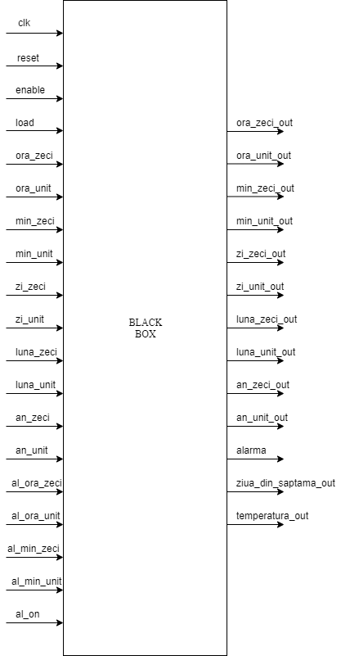

2.2 C.U. and E.U.

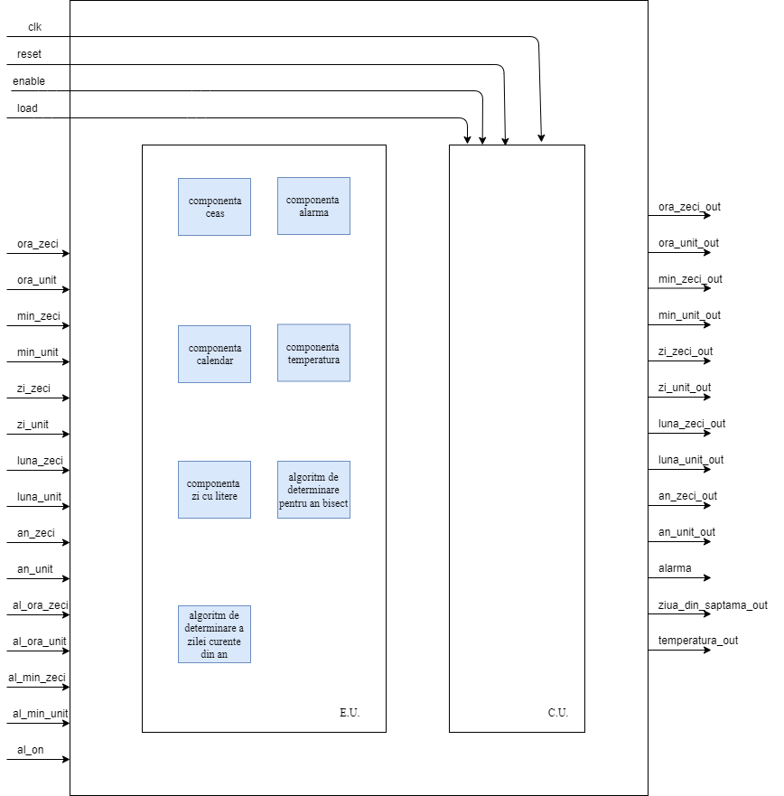

2.3 Resources

1) Componenta Ceas

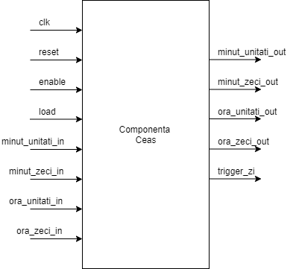

Our resources from this component are:
-Counter 0-9
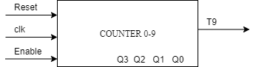
I used this counter for the units from the minutes and hour

-Counter 0-5

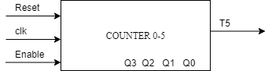

I used this counter for the tens from the minutes

-Counter 0-2

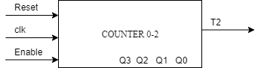

I used this counter for the tens from the hour

2) Componenta alarma

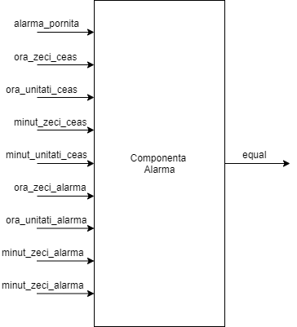

Our resources from this component are:
-Counter 0-9
I used this counter for the units from the minutes and hour for the alarm.

-Counter 0-5: I used this counter for the tens from the minutes for the alarm.

-Counter 0-2: I used this counter for the tens from the hour for the alarm.

-Comparator: will compare an input from the hours compoenent with an input from the alarm component. Ex: ora_zeci with ora_zeci_alarma.

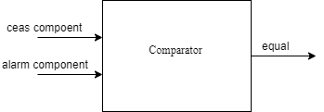

3) Componenta calendar

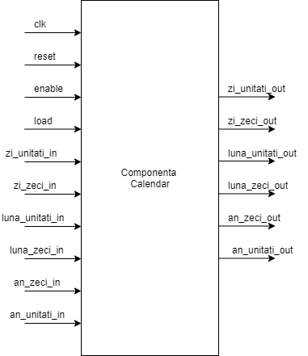

Our resources from this component are:
-Counter 0-9 : this counter is used for the units from the day,month,year and also for the tend from the year

Counter 0-3: this counter is used for the tens from the month.
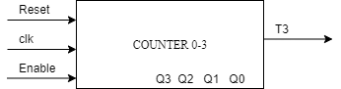

Counter 0-1: this counter is used for the tens from the month.

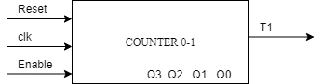

There is a comparator whici verifies if the year is over. Also there is a comparator to verify the number of days from the current month if the number its reached a trigger is sent to the month counter and also the days are reseting.

4) Componenta temperatura

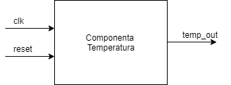
For the temperature component I used a random number generator. This will generate a number for every day.

5) Componenta zi cu litere

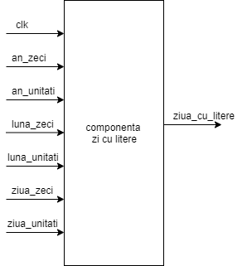

For the day with letters component I used an algorithm.
The algorithm basically works this way:
- First we are given an array which contains for every month a number , it’s called magic month array.
- For each century we are given a value for our current century its 6
- We will take the last two digits of the year and divide it by 4 and remember the result
- We take the day (our current day)
- we take the month value from the magic month array
- take the century value also
- we will do the sum of the four items enumerated above and after divide by 7
- the result will be our current day
- for 0->SUN
- 1->MON 2->TUE 3->WED 4->THU 5->FRI 6->SAT.

Leap Year algorithm

To determine whether it’s a leap year or not I use another algorithm which is working according to the following circuit

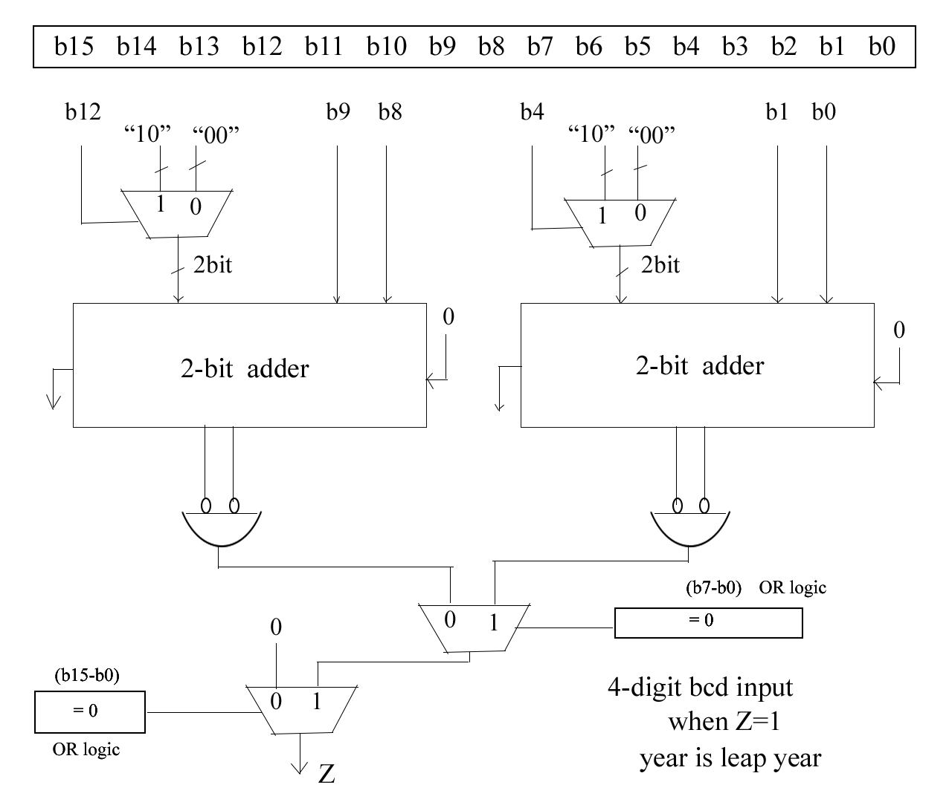

After all the computations if our signal bisect is one then the current year is a leap year , if its zero then it’s a normal year.

2.4 State diagram

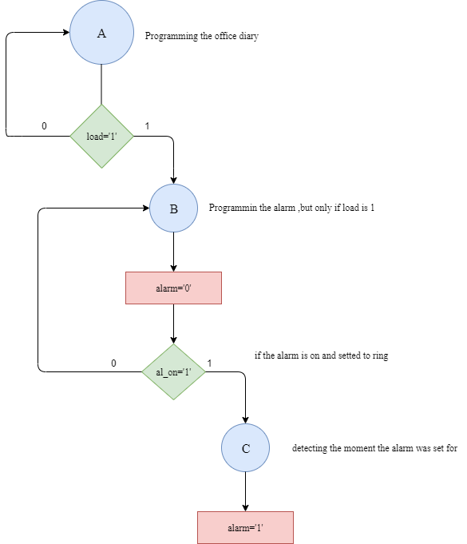

3. Justification for the chosen solution

I choose to implement my project this way ,because this was the easiest way for me. Using counters, comparators and other combinational logic elements , but also some sequential code. I used counters for digits to be easy to increment the digits from the dates. The algorithms I used were a must to my project to work properly.

4. Possible updates for a better efficiency

Probably the most important update for a way better efficiency would be to change the initial set up that is needed for the watch, alarm and calendar component.

5. Instructions
- Set up al the dates starting from the units from the minutes to the tens from the year
- Activate load and be careful enable is inactive so the agenda could start from the dates you set up
- Activate enable and the agenda will start working
- You can set up an alarm all you need to do is to activate load and after that activate enable so the watch will start working and its very important after setting up the alarm you must give al_on the value 1 , the alarm will be activated every day until al_on is active

6.bibliography
For the leap year:
https://linus5.blogspot.com/p/leap-year-combinational-circuit.html
for the determination of the current day of the week:
https://www.geeksforgeeks.org/find-day-of-the-week-for-a-given-date/

